**UERM Medical Center, AC Health Enters Strategic Partnership**

**The collaboration aims to elevate healthcare standards and accessibility across the country**

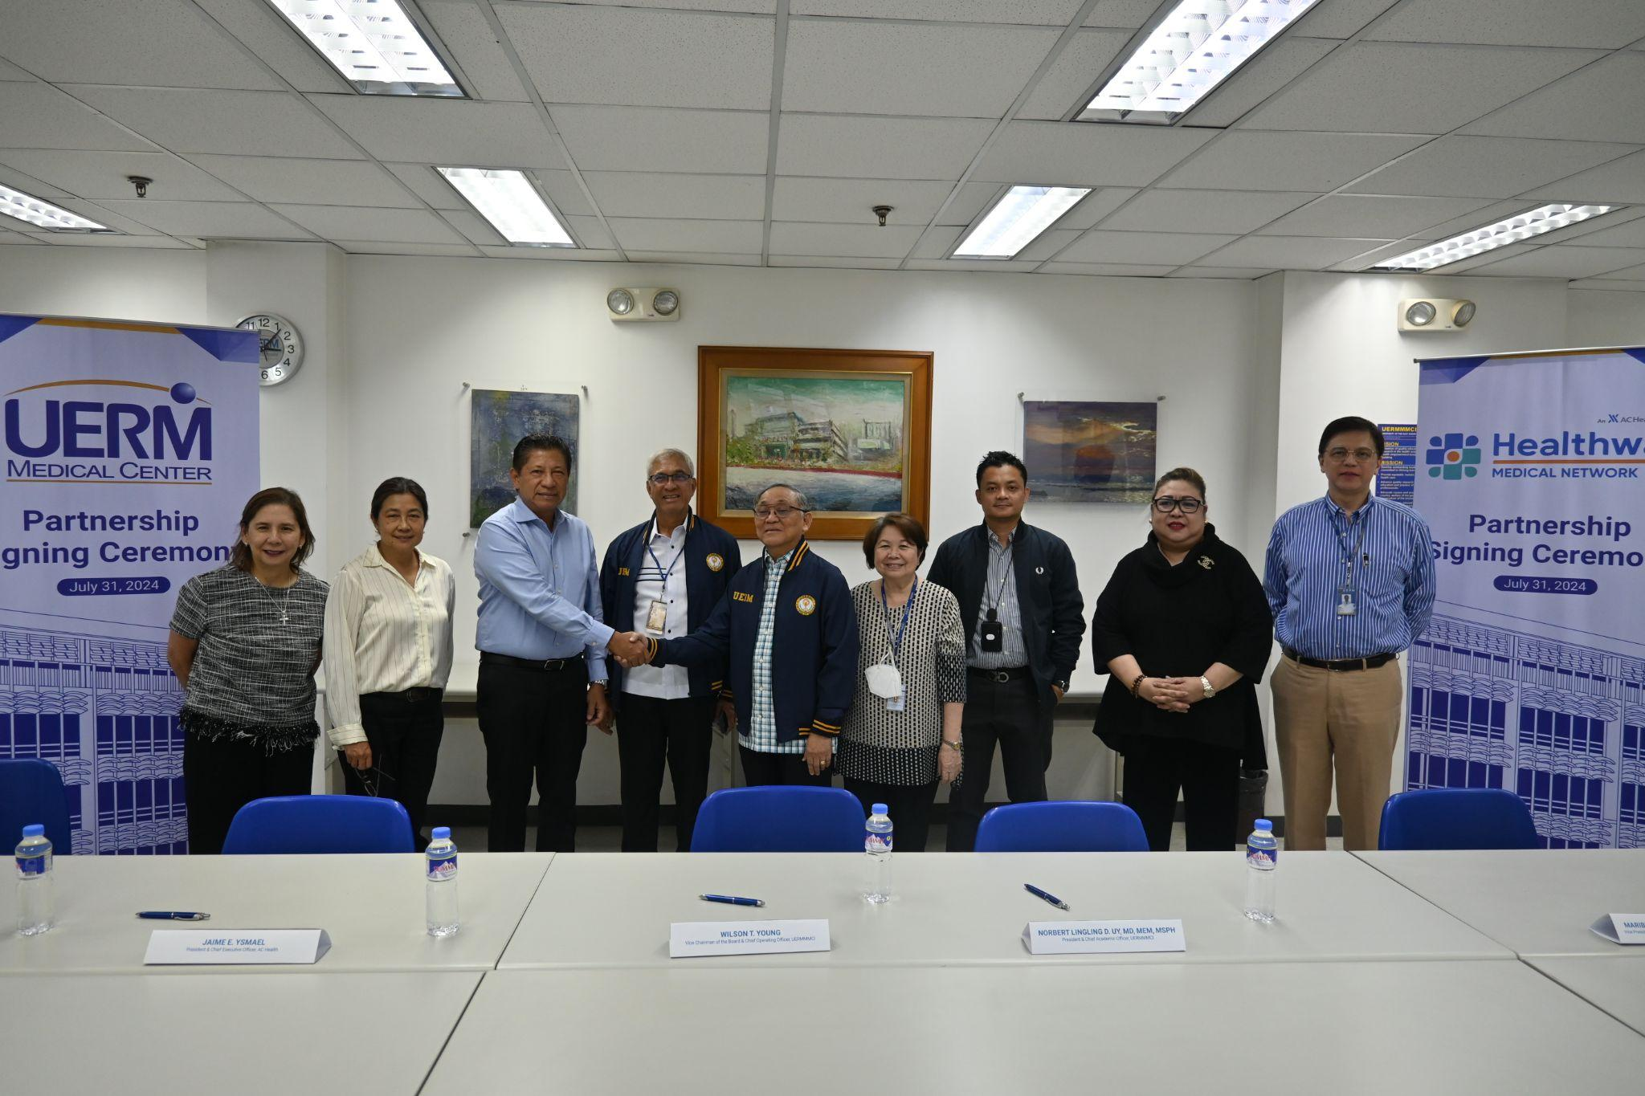

UERM Medical Center and AC Health join forces to enhance healthcare education and services in the Philippines.

**Quezon City, Philippines** - To further advance healthcare education and health care services for Filipinos, the UERM Medical Center and Ayala Healthcare Holdings, Inc. (AC Health) have entered a partnership, marking a significant step in leveraging the strengths of both institutions to improve healthcare accessibility and quality in the country.

The Signing Ceremony was joined by UERM Medical Center Vice Chairman of the Board & Chief Operating Officer Wilson T. Young, President & Chief Academic Officer Dr. Norbert Lingling D. Uy, and Vice President for Hospital Services & Chief Medical Officer Dr. Maribeth T. de Los Santos. Representing Healthway President & Chief Executive Officer Jaime E. Ysmael, Chief Finance Officer Ruby P. Chiong, and Chief Strategy & Business Development Officer Margaret E. Bengzon.

“This partnership underscores and strengthens UERM Medical Center and AC Health’s dedication to fostering excellence in healthcare education and delivery, contributing to the overall improvement of healthcare standards in the Philippines,” said Dr. Uy.

The partnership will introduce several initiatives aimed at both academic and hospital sectors. These include funding of scholarship programs by AC Health, including review classes for deserving students of UERM Medical Center’s Nursing and Medical Technology programs. Additionally, students will gain valuable hands-on experience within AC Health’s expansive network of hospitals, clinics, and pharmacies.

The partnership also focuses on enhancing professional development for medical staff and post-graduate students whereby graduates will have access to career opportunities across AC Health’s network. Collaborative research projects will also be undertaken, concentrating on clinical, public health, and health policy issues.

“Through this partnership, we are committed to fostering a new generation of healthcare professionals and improving the overall quality of healthcare services in the Philippines,” said Ysmael.

For more information, please visit <https://www.uerm.edu.ph/>

###

**About UERM Medical Center**

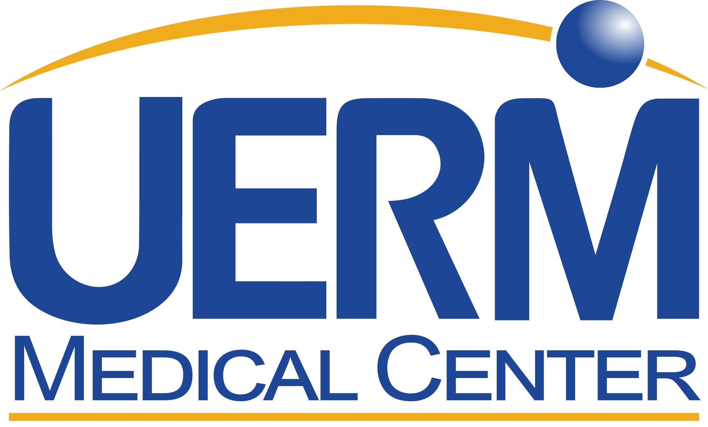

*UERM Medical Center is one of the leading healthcare facilities and world-renowned training ground for medical health professionals in the country. It has been granted a Level III Hospital Accreditation by the Department of Health, the highest level issued. The College of Medicine continues to be the only private medical school with a Level IV accreditation while the Physical Therapy program carries a Level III accreditation.*

For media inquiries, please contact:

**Mary Krizangelic Cabuslay**

Communications Specialist

UERM Medical Center

+63 956 465 3542

marketing@uerm.edu.ph